**LAB # 13**

**Task No. 1: Create webapi for restaurant named Alibaba the restaurant can be able to Post new item in menu, Get All items that restaurant offers, Put existing items, Delete items**

**Solution:**

namespace _13t1.Service

{

/// <summary>

/// Summary description for WebService1

/// </summary>

[WebService(Namespace = "http://tempuri.org/")]

[WebServiceBinding(ConformsTo = WsiProfiles.BasicProfile1_1)]

[System.ComponentModel.ToolboxItem(false)]

// To allow this Web Service to be called from script, using ASP.NET AJAX, uncomment the following line.

// [System.Web.Script.Services.ScriptService]

public class WebService1 : System.Web.Services.WebService

{

[WebMethod]

public string HelloWorld()

{

return "Hello World";

}

[WebMethod]

public int Square(int num)

{

return num * num;

}

// Add two integers and returns the sum

[WebMethod]

public int Add(int num1, int num2)

{

return num1 + num2;

}

[WebMethod]

// Multiply two integers and retuns the result

public int Multiply(int num1, int num2)

{

return num1 * num2;

}

[WebMethod]

// Subtracts small number from big number

public int Subtract(int num1, int num2)

{

if (num1 > num2)

{

return num1 - num2;

}

return num2 - num1;

}

[WebMethod]

//performing Division on two float variables.

public float Division(float num1, float num2)

{

return num1 / num2;

}

}

**Output:**

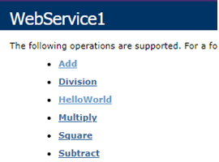

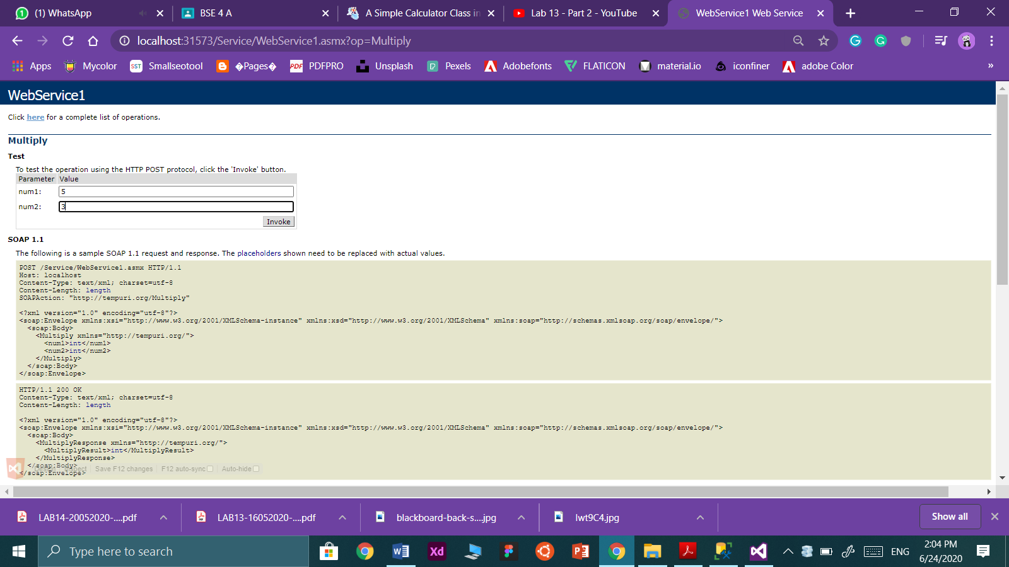

**Task 2: Createwebservicefor converting xml to json→the service take input xml as a string and return jsonconverted output of that xml.**

**Solution:**

namespace CalculatorServiceWEB.Services

{

[WebService(Namespace = "http://tempuri.orgr)]

[WebServiceBinding(ConformsTo = WsiProfiles.BasicProfile1_1)]

[System.ComponentModel.ToolboxItem(false)]

public class JSONtoXML : System.Web.Services.WebService

{

public object JsonConvert { get; private set; }

[WebMethod]

public string XMLConverter(string xml)

{

XmlDocument doc = new XmlDocument();

doc.LoadXml(xml);

string jsonText = JsonConvert.SerializeXmlNode(doc);

return jsonText;

}

}

}

**Output:**

